**History of Linux**

In earlier days, computers were as big as houses or parks. So, you can imagine how difficult it

was to operate them. Moreover, every computer has a different operating system which made it

completely worse to operate on them. Every software was designed for a specific purpose and was

unable to operate on another computer. It was extremely costly and normal people neither can afford

it nor can understand it.

|  |  |  |  |
| --- | --- | --- | --- |
| 1969 | Unix | Ken Thompson | Developed at AT&T Bell Lab. Not Free |
| 1983 | GNU Project | Richard Stallman | Free version of UNIX |
| 1991 | Linux | Linus Torvald | Make first Linux kernel which is freely available to anyone |

Linux is a kernel and not an operating system.

A Linux distribution(os) is the combination of Linux kernel and a collection of software (GNU) that together, called an OS.

Linux is not a UNIX derivative. It was written from scratch.

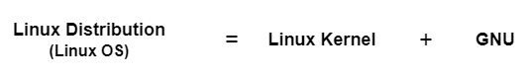

**Features of Linux**

**1) Open Source**

* + The source code of Linux OS is openly available to anyone.
  + Anyone can open it, expand it and modify it as required.
  + We can create our own OS by using Linux code.
  + Simply open-source means have freedom to:
  + run program, for any purposes.
  + study how program works and change it.
  + distribute versions.

**2) Free**

* Free to use this OS for personal use, on the server, and for educational use.
* A free License and collaborative project that can be developed by the user contribution.

**3) Security**

* Linux is more secure OS.
* It provides Limited permissions.
* Super user and standard user having different privileges.
* Open source- allowing anyone to inspect, modify and improve code enable large community to fix vulnerabilities
* A global development community look at different ways to enhance its security, hence it is highly secured and robust so we don't need an antivirus to scan it regularly**.**

**4) Lightweight**

* + Linux required less hardware resources.
  + 4-8 GB hard disk space required to install.
  + It can be installed on any small hardware and it uses quite small disk space while installation.

**5) Multi-user Capability**

* + Linux operating system allows and grants permission to multiple users to access underlying hardware resources simultaneously.
  + Multiple users can access the same system resources like CPU, memory, hard disk, etc.

**6) Multi-tasking**

* It allows multiple users to work on various tasks at once.
* Single users doing multiple tasks.
* Multiple users do multiple tasks which includes editing file and using browsing facility at the same time.

**Linux Distributions**

* Linux has number of different versions for from new users to hard core users.
* Linux distributions are various versions of the Linux operating system that bundle the Linux kernel with other software packages, tools, and applications.
* Nearly every version of Linux is free to download.

**Popular Linux distributions include:**

* REDHAT
* AMAZON LINUX
* LINUX MINT
* MANJARO
* DEBIAN
* UBUNTU
* ANTERGOS
* FEDORA
* ELEMENTARY OS

**Architecture Of Linux OS**

Linux architecture consist of inner most Hardware layer, kernel, shell, and outer application layer.

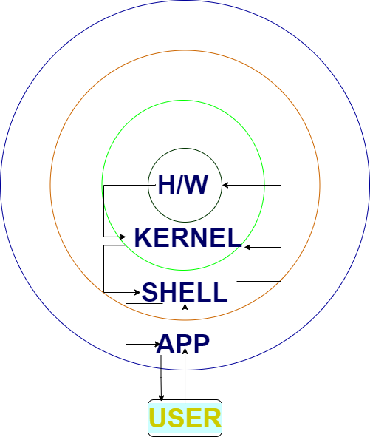

**1) Application Layer:**

* Users interact with the system through varies applications such as office, games etc.
* These applications are run in outer most layer of architecture.

**2) Shell:**

* Shell provides environment to run any application.
* It provides interface to the user to interact with hardware and act as command interpreter.
* It converts high level language into computer level language (binary language).
* Shell can be of:

Graphical Shell, Command line Shell

* Examples: k shell, bash shell, sh shell, etc.

**3) Kernel:**

* Kernel is core component of Linux architecture.
* It manages hardware’s (CPU, Memory, Storage and devices).
* It controls process management, memory management and device management.
* It tracks all active processes running on systems.
* In Linux, we use Monolithic kernel.

**4) Hardware:**

* All the hardware components such as motherboard, CPU, hard disk etc. are comes under

this layer.

**Monolithic kernel vs microlithic kernel**

**Monolithic Kernel**

* It manages system's resources between system applications and system hardware which are required for system applications are already installed.
* Large in size and provides high execution speed.
* All prerequisites are already installed required to install new packages.
* It offers memory management, file management and process scheduling.

**Microlithic kernel**

* In microlithic kernel only required dependencies are pre-installed.
* lightweight in size
* Application software’s running on microlithic architecture have ability to install its own dependencies by itself.
* It is slow in execution.